Q | Scheme | Marks | AOs | Pearson Progression Step and Progress descriptor
1a | Substitutes (2, 400) into the equation. 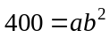 | M1 | 1.1b | 6th  Set up, use and critique exponential models of growth and decay.
1a | Substitutes (5, 50) into the equation. 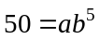 | M1 | 1.1b
1a | Makes an attempt to solve the expressions by division. For example, 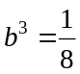 (or equivalent) seen. | M1 | 1.1b
1a | Solves for b. b = 0.5 or 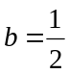 | A1 | 1.1b
1a | Solves for a. a = 1600 | A1 | 1.1b
1a |  | (5)
1b | Divides by ‘1600’ and takes logs of both sides. 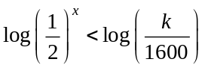 | M1ft | 1.1b | 5th  Understand and use the three laws of logarithms.
1b | Uses the third law of logarithms to write 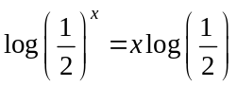 or 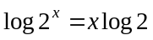 anywhere in solution. | B1 | 2.1 | 5th  Understand and use the three laws of logarithms.
1b | Uses the law(s) of logarithms to write 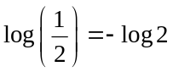 anywhere in solution. | B1 | 2.1 | 5th  Understand and use the three laws of logarithms.
1b | Uses above to obtain 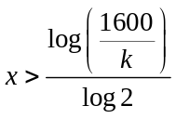* | A1* | 2.1 | 5th  Understand and use the three laws of logarithms.
1b |  | (4)
(9 marks)
Notes

Q | Scheme | Marks | AOs | Pearson Progression Step and Progress descriptor
2 | Uses appropriate law of logarithms to write 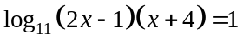 | M1 | 3.1a | 5th  Solve simple logarithmic equations using the laws of logs.
2 | Inverse log₁₁ (or 11 to the) both sides. 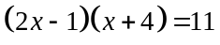 | M1 | 1.1b
2 | Derives a 3 term quadratic equation. 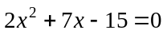 | M1 | 1.1b
2 | Correctly factorises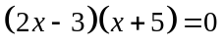or uses appropriate technique to solve their quadratic. | M1 | 1.1b
2 | Solves to find 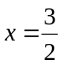 | A1 | 1.1b
2 | Understands that 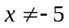stating that this solution would require taking the log of a negative number, which is not possible. | B1 | 3.2
(6 marks)
Notes

Q | Scheme |  | Marks | AOs | Pearson Progression Step and Progress descriptor
3a | Figure 1  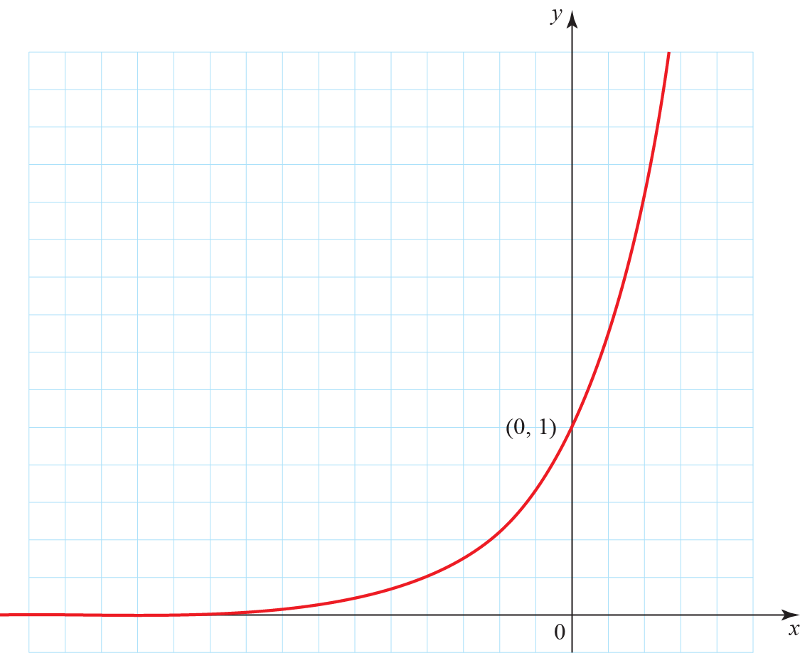 | Graph has correct shape and does not touch x-axis. | M1 | 3.1a | 3rd  Sketch the graph of y = a^{x} (for a > 1)
3a |  | The point (0, 1) is given or labelled. | A1 | 3.1a | 3rd  Sketch the graph of y = a^{x} (for a > 1)
3a |  |  | (2)
3bi | Translation 1 unit right (or positive x direction) or by 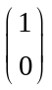 |  | B1 | 2.2a | 5th  Transform the graphs of exponential functions using translations and stretches.
ii | Translation 5 units up (or positive y direction) or by 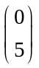 |  | B1 | 2.2a
 |  |  | (2)
(4 marks)
Notes

Q | Scheme | Marks | AOs | Pearson Progression Step and Progress descriptor
4 | Correctly factorises. 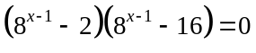  (or for example, 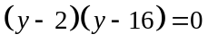) | M1 | 1.1b | 5th  Solve exponential equations using logarithms.
4 | States that 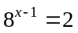, 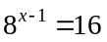 (or y = 2, y = 16). | A1 | 1.1b | 5th  Solve exponential equations using logarithms.
4 | Makes an attempt to solve either equation (e.g. uses laws of indices. For example, 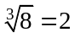 or 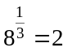 or 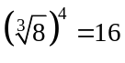 or 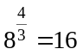 (or correctly takes logs of both sides). | M1 | 2.2a | 5th  Solve exponential equations using logarithms.
4 | Solves to find 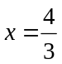 o.e. or awrt 1.33 | A1 | 1.1b | 5th  Solve exponential equations using logarithms.
4 | Solves to find 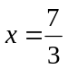 o.e. or awrt 2.33 | A1 | 1.1b | 5th  Solve exponential equations using logarithms.
4 |  | (5)
(5 marks)
Notes
4
2nd M mark can be implied by either 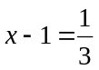 or 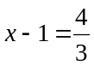

Q | Scheme |  | Marks | AOs | Pearson Progression Step and Progress descriptor
5a | Figure 2  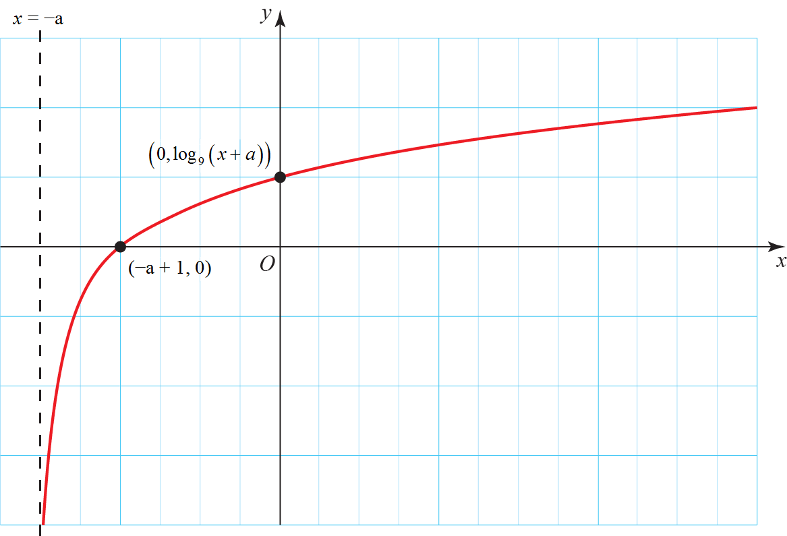 | Attempt to find intersection with x-axis. For example, 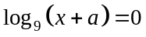 | M1 | 1.1b | 4th  Sketch the graph y = log(x).
5a |  | Solving to find x = −a + 1, so coordinates of x-intercept are (−a + 1, 0) oe | A1 | 1.1b | 4th  Sketch the graph y = log(x).
5a |  | Substituting x = 0 to derive 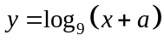, so coordinates of y-intercept are 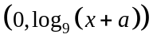 | B1 | 3.1a | 4th  Sketch the graph y = log(x).
5a |  | Asymptote shown at x = −a stated or shown on graph. | B1 | 3.1a | 4th  Sketch the graph y = log(x).
5a |  | Increasing log graph shown with asymptotic behaviour and single x-intercept. | M1 | 3.1a | 4th  Sketch the graph y = log(x).
5a |  | Fully correct graph with correct asymptote, all points labelled and correct shape. | A1 | 2.2a | 4th  Sketch the graph y = log(x).
5a |  |  | (6)
5b | 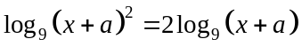seen. |  | M1 | 2.1 | 5th  Understand and use the three laws of logarithms.
5b | The graph of 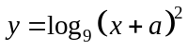is a stretch, parallel to the y-axis, scale factor 2, of the graph of . |  | A1 | 2.2a | 5th  Understand and use the three laws of logarithms.
5b |  |  | (2)
(8 marks)
Notes
5a
Award all 5 points for a fully correct graph with asymptote and all points labelled, even if all working is not present

Q | Scheme | Marks | AOs | Pearson Progression Step and Progress descriptor
6a | Makes an attempt to subsitute 7 into the equation, for example, 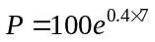seen. | M1 | 1.1b | 4th  Understand the properties of functions of the form a^{x}.
6a | 1644 or 1640 only (do not accept non-integeric final answer). | A1 | 3.4
6a |  | (2)
6b | It is the initial bacteria population. | B1 | 2.2a | 4th  Understand the properties of functions of the form a^{x}.
6b |  | (1)
6c | States that 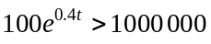 or that 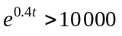 | M1 | 3.4 | 6th  Set up, use and critique exponential models of growth and decay.
6c | Solves to find 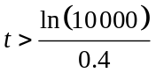 | M1 | 1.1b
6c | 24 (hours) cao (do not accept e.g. 24.0). | A1 | 3.5
6c |  | (3)
(6 marks)
Notes

Q | Scheme | Marks | AOs | Pearson Progression Step and Progress descriptor
7a | Uses the equation of a straight line in the form  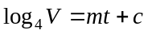 or 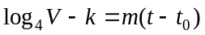 o.e. | M1 | 1.1b | 6th  Set up, use and critique exponential models of growth and decay.
7a | Makes correct substitution. 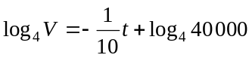 o.e. | A1 | 1.1b
7a |  | (2)
7b | Either correctly rearranges their equation by exponentiation  For example, 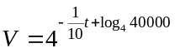 or takes the log of both sides of the equation 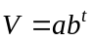. For example, 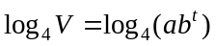. | M1 | 1.1b | 6th  Set up, use and critique exponential models of growth and decay.
7b | Completes rearrangement so that both equations are in directly comparable form 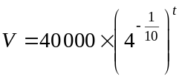 and or and 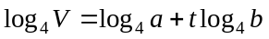. | M1 | 1.1b
7b | States that a = 40 000 | A1 | 1.1b
7b | States that 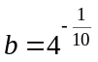 | A1 | 1.1b
7b |  | (4)
7c | a is the initial value of the car o.e. | B1 | 2.2a | 6th  Set up, use and critique exponential models of growth and decay.
7c | b is the annual proportional decrease in the value of the car o.e. (allow if explained in figures using their b. For example, (since b is ≈0.87) the car loses 13% of its value each year.) | B1 | 2.2a
7c |  | (2)

7d | Substitutes 7 into their formula from part b. Correct answer is £15 157, accept awrt £15 000 | B1ft | 3.4 | 4th  Understand the properties of functions of the form a^{x}.
 |  | (1)
7e | Uses 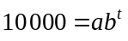 with their values of a and b or writes 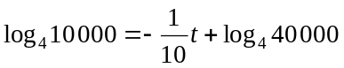 (could be inequality). | M1 | 3.4 | 5th  Solve exponential equations using logarithms.
7e | Solves to find t = 10 years. | A1ft | 1.1b | 5th  Solve exponential equations using logarithms.
7e |  | (2)
7f | Acceptable answers include.  The model is not necessarily valid for larger values of t.  Value of the car is not necessarily just related to age.  Mileage (or other factors) will affect the value of the car. | B1 | 3.5b | 6th  Set up, use and critique exponential models of growth and decay.
7f |  | (1)
(12 marks)
Notes
7b
2nd M mark can be implied by correct values of a and b.
7c
Accept answers that are the equivalent mathematically. For example, for b. the value of the car in 87% of the value the previous year.

